**Finding The Hotspot For Mobile Phone Expo – 2020**

Iyyanar M

January 02, 2020

*Applied Data Science Capstone – IBM Data Science Professional Certificate on Coursera*

**1. Introduction**

**1.1 Background**

A Mobile Phone Expo in India for the year 2020 has been planned and the location for the expo is still undecided. This Expo will act as a marketing campaign for major mobile phone manufacturers and local mobile stores around the location. Customers can purchase a new mobile phone and also they can get to know the local stores, service points nearby from the expo.

**1.2 Problem**

The problem is to find the central hub-point, which should be located in middle of many mobile shops in a lesser distance. So, that expected amount of sponsors and customers around that area will be guaranteed to participate in the expo. Therefore, the cost of installing the expo can be reduced by more number of sponsors and profit of the expo will be increased.

**2.Data Acquisition and Cleaning**

**2.1 Data Sources**

I have used the Foursquare API for collecting the mobile shop location data's which includes latitude and longitude values for 5 major cities in India. The Cities are Bangalore, Chennai, Delhi, Hyderabad and Mumbai. The reason behind these 5 Cities are that these cities are well known for their daily market trade and populations.

**2.2 Data Cleaning**

The Data retrieved from the FourSquare API is in JSON format containing many information, which are not needed. The information only needed for this project are shop name, latitude, longitude and city name. By using python script, only the needed data columns are selected from the JSON results.

**2.3 Feature Selection**

Once the data is cleaned and ready for use. We can choose which rows and columns are needed. For our purpose, only name, city, latitude and longitude values are needed and it is available in the df_cities data frame. Below Fig-1 is the sample data screenshot.

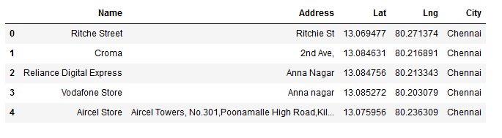

Fig. 1 – Screenshot of the Dataset.

**3. Exploratory Data Analysis**

**3.1 Data Visualization**

The Dataset which we collected needs to be analyzed. Since, it consists of latitude and longitude values. We can plot it in a graph for analysis. Therefore, the five cities are plotted individually with the data points on it by using folium maps.

Folium is a map visualization library available in python for visualization of geographical locations based on their latitude and longitude values. We have the latitude and longitude values of each city and it mobile shops. So, we can plot it for visualization. Below Fig- 2 to 6 are the screenshot of all the 5 cities mobile shop locations in the map.

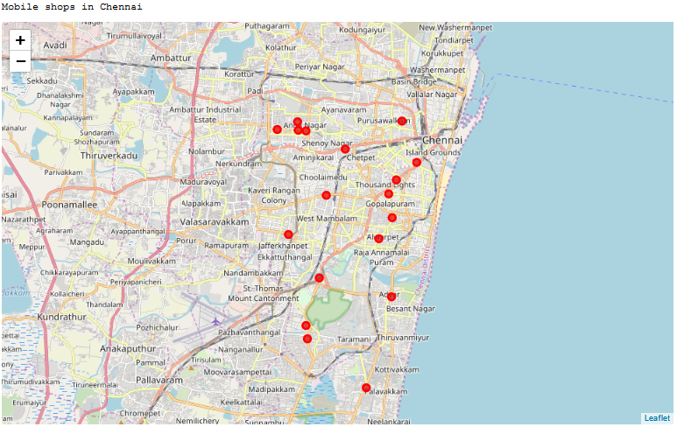

Fig 2 – Mobile shops in Chennai

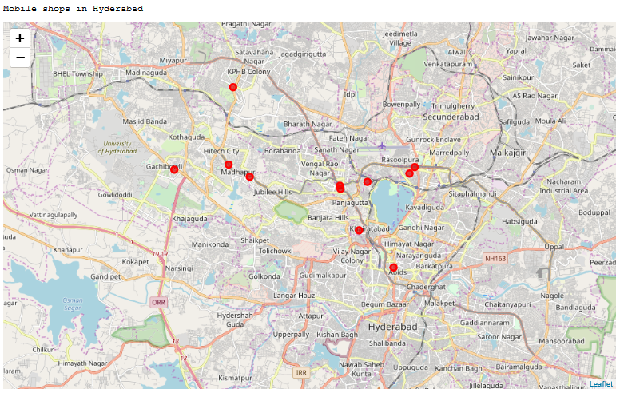

Fig 3 – Mobile shops in Hyderabad

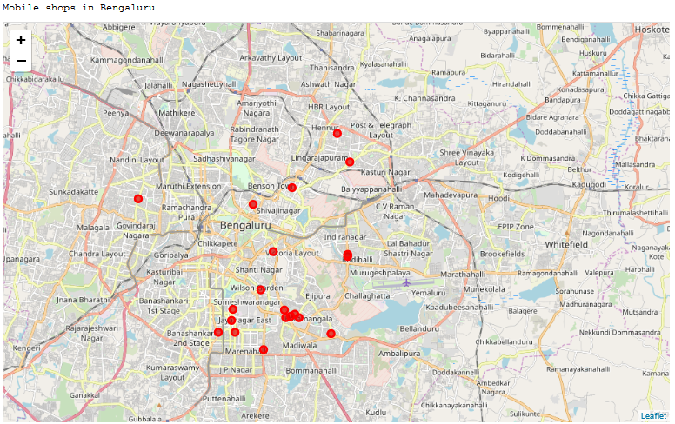

Fig 4 – Mobile shops in Bengaluru

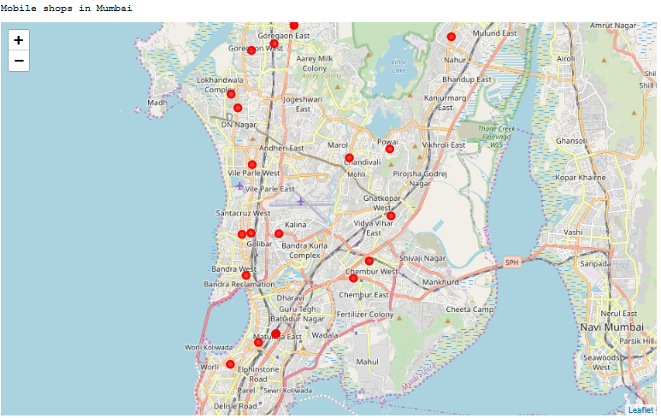

Fig 5 – Mobile shops in Mumbai

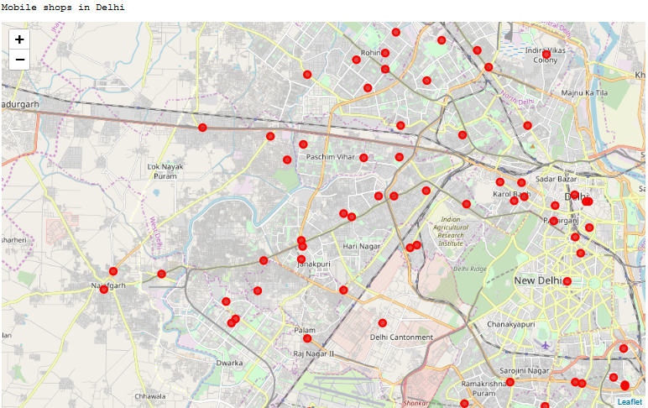

Fig 6– Mobile shops in Delhi

**3.2 Calculation of Centre Point and Measure of Distance for Each Cities**

Each city has n- number of mobile shops. The calculation of the distance from a central point of those mobile shops in each city would be helpful in identifying the best city with higher number of mobile shops and also helps to find the average distance to be travelled for the Expo-2020. Below Fig- 7 shows the screenshot of average distance to central point to all the mobile shops.

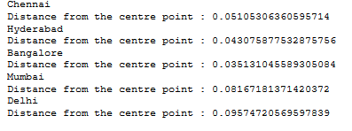

Fig. 7 – Distance from centre point in each cities.

#### These centre points are calculate by the mean average of the latitude and longitude values of each cities. The Central Hub point for Delhi seems bit far location for some mobile shops. So, We can create a cluster of 3 in the above map. We will find a central point for each cluster to determine the expo location for delhi.

**4. Cluster Analysis**

**4.1 K-means Clustering Algorithm**

K-Means algorithm is an unsupervised learning algorithm. It clusters, partitions or segments the available data points by means of similar characteristics based on labels. The available data points are divided into non-overlapping subsets called clusters without any internal cluster structure.

Algorithm :

1. Randomly placing *k* Centroids, one for each cluster
2. Calculate the distance of each point from each centroid
3. Assign each data point to its closest centroid, creating a cluster
4. Recalculate the position of the *k* centroids
5. Repeat the steps 2-4, until the centroids no longer move.

After applying the k-means algorithm to the data points for delhi city with a *k* cluster value. We got the cluster labels for each row in the delhi dataset. Below Fig-8 is the screenshot of delhi data which is merged with cluster labels.

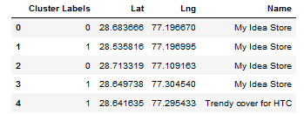

Fig 8. Delhi data with their cluster labels.

By using this cluster label, we can find the center point for each cluster to start expo in that place. The center point can be calculated by the mean average of latitude and longitude values for all the points available in each cluster.

**5. Results**

The Result is the center hub point for each segmented cluster in Delhi. There are 3 clusters of mobile shops located in this city and the center mid-point for each cluster can be used for starting the Expo-2020. Fig-9 is the screenshot of the Delhi city with its clusters and center points.

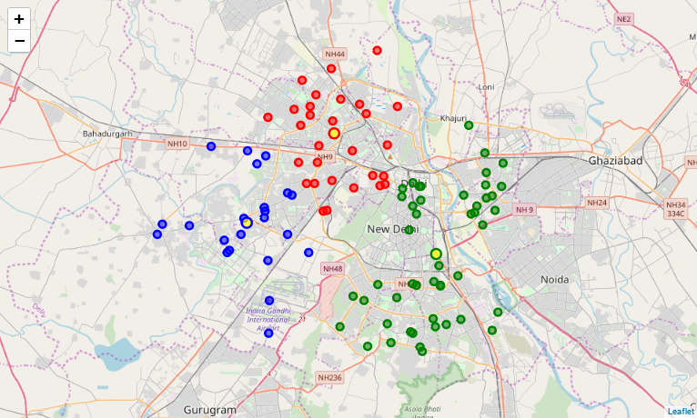

Fig 9. Cluster of mobile shops in Delhi city.

The three clusters are plotted in the graph having a differentiation of markings in colors as red, green, and blue. Each cluster has its own center points highlighted with yellow color.

**6. Conclusion**

The project work for finding the hotspot location to start a Mobile Expo-2020 in India has been found as Delhi. Therefore, the distance from the mobile shops to the expo will be lesser and will result in participation of higher number of mobile stores, sponsors, and customers. Which will increase the popularity and sales profit of all the mobile stores around Delhi.